**Member**

Chananya Laopon 62110037

Pitchaya Kuphanlam 62110071

Supachok Catavanit 62110122

Kanyakorn Kaewsaard 62110035

**• The system architecture**

IDE : Visual studio code

Languages : HTML,CSS,Java Script

CSS library : Bootstrap

Awesome Font

Owl carousel

JS library : Bootstrap

        Jquery

**• General overview of the library**

Bootstrap : Use for design and animation

Awesome Font : Use icon from this library

Jquery : Use for Animation

Owl carousel : use for Transition animation

**• Important design**

We separated our information to be 3 pages and Home page for all information of our hotel first page is about room it will told customer about price and facility of our hotel second pages is About us this page will show all over of our staff information and last page is Contract Us this page have information about how to contract us and have form that customer can typing instantly and sent to our email.

**• Test scenarios**

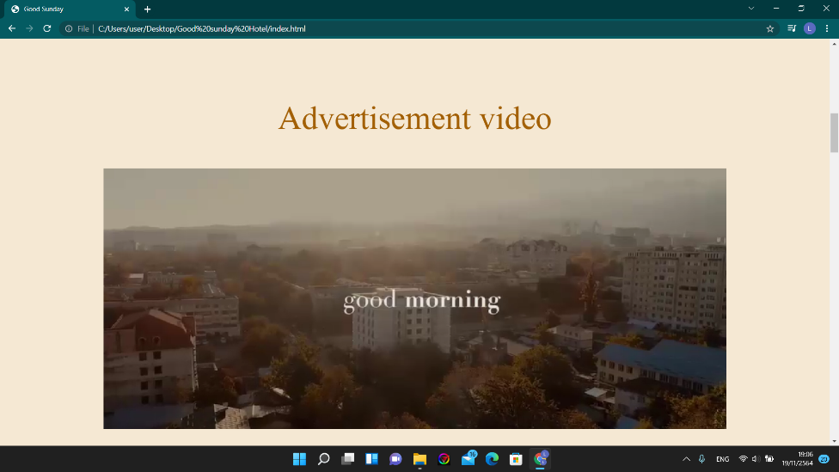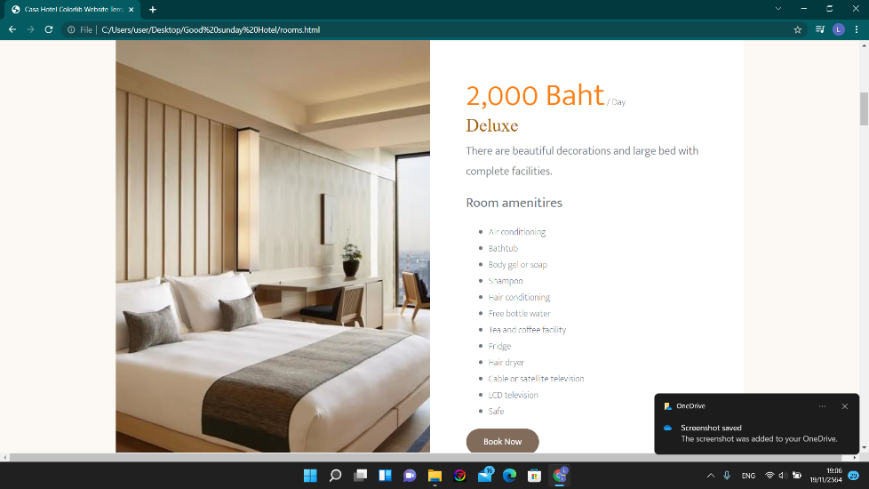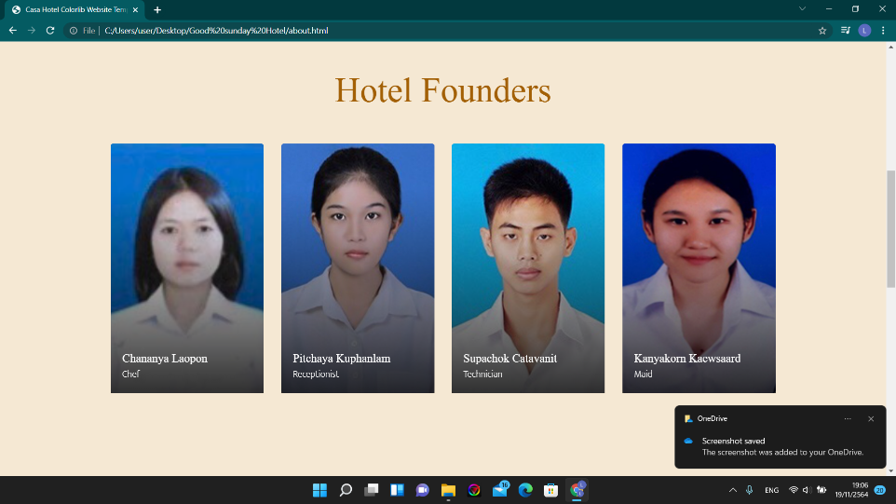

**•How We work**

Firstly we gather all of our information and Design our Prototype Website by using Dreamwever. Next we download all of framework that we want to use like Bootstrap, Jquery, Owl carousel, etc. Next We create our Html Template and call all of plugin to use at head. We set our theme at the bootstrap css file. And the we put our information to our page that we plan before.

**•User manuals that explain how to install and run your program**

First you can click the index for our first page at the top-left of nav bar we have hamburger menu for selecting what page you need to go next. If you want to open code you can right click at the html files and open with your IDE

Ps. We can’t use the auto play music anymore in the new version because browser was update privacy for auto play function that auto play function can muted only